COURSE NAME: ITECH_3208 PROJECT-1

LECTURER: UMESH POUDEL

SUBMITTED BY: DENIS THAPA

SUBMITTED ON: 28.08.2020

|  |
| --- |
| **PROJECT VISION DOCUMENT** |

|  |
| --- |
| **GROUP 3**  **JOB POSTING API** |

|  |  |  |
| --- | --- | --- |
| **Student Name** | **Student ID** | **Role** |
| Ganesh Pokhrel | 30387561 | Product Owner |
| DENIS THAPA | 30383367 | Scrum Master |
| Saroj Kafle | 30369670 | Team Member |
| Sagar Bhattarai | 30379752 | Team Member |
| Saurabh Shankhi | 30383246 | Team Member |

# Introduction

This Project’s initial plan include about the introduction of the organization and processes which provide hand to complete the project JPA (Job Posting API). In this assignment we include about the organizational process, initial plan and managerial process. Here the project plan includes the process model which provide a high-level breakdown of the activities in the project. Moreover, it also includes the plan of project which consists of high-level outcomes for each sprint. In order to complete this project, various tool and technique are amplified.

# Organization

## Process Model

As we have mentioned on the backlog, we would be using the agile model to build this project. In this process model, the requirements and solutions are coming through collaboration between self-organizing and cross-functional teams. Also, this model is based on iterative development thus, sprint is guided by the project’s functions and requirements. Here, the sprint is provided in order to accomplish the project effectively.

The required action and function to be done are noted by the initial product backlog. This helps to identify the requirement of the project. The project plan helps to know and understand about the activities to be done / required to be done to achieve the project objectives and their functionalities. Then after, to keep the track of the activities ongoing/to be done, the sprint backlog is required. Now, we are in the development phase of the project. Hence, as we updated and procced the processes will be updated eventually.

## Work Breakdown Structure

The project task includes many scope, key tools and techniques so we need to break down the work according to the task and project members. here, we subdivide project deliverables and project work into similar more manageable components and regroup in a structured document. This is process is known as work break down structure. The WBS is created for the scope management which documents how the project will be defined, validated and controlled. Overall, it helps to provide guidance and direction to the project. Similarly, we create WBS for planning and managing project schedules, costs, resources and changes. The WBS for Job Posting API project is given below:

Figure a: Overview of Work Breakdown Structure

## Time Management

Time management plays vital role in process of project management. The scheduling of the project task is crucial and important to complete the project on time effectively. In this project, we decided to use the Milestones and Gantt charts to create a schedule of the project. The project starts from 23rd August 2020 and ends on 13th October 2020. The task has been divided into five major phases they are initiating, planning, processing, sprint review and backlog and closing. We have used the agile scrum methodology for software development life cycle.

|  |  |  |  |
| --- | --- | --- | --- |
| **Task** |  | **End Date** | **Duration** |
| **1. Initiating** | 11/08/2020 | 23/08/2020 | 12 |
| 1.1 Assign Project Manager | 11/08/2020 | 12/08/2020 | 1 |
| 1.2 Requirement Analysis | 12/08/2020 | 15/08/2020 | 3 |
| 1.3 Create Product Backlog | 16/08/2020 | 23/08/2020 | 7 |
| **2. Planning** | 17/08/2020 | 20/09/2020 | 34 |
| 2.1 Project Vision, scope plan | 17/08/2020 | 23/08/2020 | 6 |
| 2.2 WBS and Schedule | 23/08/2020 | 27/08/2020 | 4 |
| 2.3 Organizational Structure | 23/08/2020 | 28 /08/2020 | 5 |
| 2.4 Managerial Process | 23/08/2020 | 29/08/2020 | 6 |
| 2.5 Technical Process | 23/08/2020 | 29/08/2020 | 6 |
| 2.7 Create High Level Project Plan | 23/08/2020 | 30/08/2020 | 7 |
| 2.8 Define Non- Functional Requirements | 31/08/2020 | 06/09/2020 | 6 |
| 2.9 Software and System Architecture | 06/08/2020 | 20/09/2020 | 45 |
| **3. Sprint Backlog** | 05/08/2020 | 21/05/2021 | 289 |
| 3.1 Iteration1 | 05/08/2020 | 13/09/2020 | 39 |
| 3.2 Iteration 2 | 14/09/2020 | 11/10/2020 | 27 |
| 3.3 Iteration 3 | 09/03/2021 | 02/04/2021 | 24 |
| 3.4 Iteration 4 | 03/04/2021 | 29/04/2021 | 26 |
| 3.5 Iteration 5 | 30/04/2021 | 21/05/2021 | 21 |
| **4. Sprint Review** | 13/09/2020 | 29/05/2021 | 258 |
| 4.1 Meeting | 13/09/2020 | 14/09/2020 | 1 |
| 4.2 Status Reports | 14/09/2020 | 09/05/2021 | 237 |
| 4.4 Update plans | 09/05/2021 | 13/05/2021 | 4 |
| 4.5 Final Report | 15/05/2021 | 18/05/2021 | 3 |
| **5. Sprint Retrospective** | 19/05/2021 | 29/05/2021 | 10 |

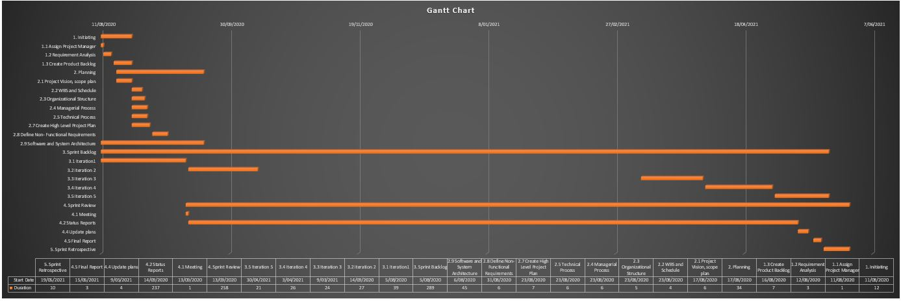

Figure b Gantt Chart for this project

The project is defined, and its requirement are assembled by using the SCRUM methodology. The regular inspections and review are carried out by doing daily scrum meeting to keep the project on target. A sprint retrospective is held to improve the next sprint, at the end of each iteration.

We as a team, carried out a various activity during the project they are:

* We regularly keep update on sprint goal and also to the release goal, during sprint.
* To complete the goal on time, we held a scrum meeting regularly to keep the member updated and informed to what do next.
* Finally, at the end of each sprint we use a retrospective meeting to enhance performance and planning if necessary, on next sprint.

The activities/task completed assigned for each sprint are tabulated below:

**Iteration 1**

1. Task allocation and set Sprint Goal
2. Meeting for finalizing the user stories
3. Prototype of product
4. Working on four user stories US1, US2, US3,US4
5. Design, Develop, Testing
6. Daily meeting for status reports
7. Development Demonstration 1
8. Sprint review

**Iteration 2**

1. Set Sprint 2 Goal
2. Meeting for finalizing the next user stories with prioritization(High, Low, Medium)
3. Working on five User Stories US5, US6, US7, US8, US9.
4. Design, Develop, Testing
5. Daily Meeting Minutes
6. Development Demonstration 2
7. Sprint Review
8. Product BETA Release

**Iteration 3**

1. Set Sprint 3 Goals and Agenda
2. Selecting the nest user stories to work on.
3. Working on user stories US10, US11, US12, US13, US14, US15, US16.
4. Design, Develop, Testing
5. Daily Meeting Minutes
6. Development Demonstration 3
7. Sprint Review

**Iteration 4**

1. Sprint 4 Goals
2. Working on the remaining all the user stories
3. Design, Develop, Testing
4. Daily Scrum Meeting
5. Development Demonstration 4
6. Sprint Review

**Iteration 5**

1. Set Sprint 5 Goals
2. Complete the unfinished user stories and work on update.
3. Checking all the requirements compare with the product.
4. Design, Develop, Testing
5. Daily Scrum Meeting
6. Development Demonstration 5
7. Sprint Review
8. Final Testing
9. Product Release

# References

*Agile Sprint Planning | Iteration Planning*. (n.d.). Retrieved from Digital.ai: https://digital.ai/resources/agile-101/agile-sprint-planning-iteration-planning#:~:text=The%20Iteration%20or%20Sprint%20Planning,between%201%20and%204%20weeks.

*What are Scrum Ceremonies?* (n.d.). Retrieved from Visual-paradigm.com: https://www.visual-paradigm.com/scrum/what-are-scrum-ceremonies/

*What is Scrum? Methodology and Project Management | Nutcache*. (n.d.). Retrieved from Nutcache: https://www.nutcache.com/blog/what-is-scrum-methodology-and-project-management/